Table of Contents
1Heading 1 3
2heading 2 3
3Heading 3 3
4How to use the system 4
4.1Birth Registrations 4
4.1.1Birth Registration 4
4.1.2Still Birth Registrations 4
4.1.3Birth Registration Approvals 4
4.1.4Birth Confirmation Print 4
4.1.5Birth Confirmation 4
4.1.6Birth Confirmation Pending Approval 4
4.1.7Print Birth Certificate 4
4.2Death Registration 5
4.2.1Death Registration 5
4.2.2Late Death Registration 5
4.2.3Sudden Death Registration 5
4.2.4Missing Death Registration 5
4.2.5Death Approve And Print List 5
4.3Adoption Registration 6
4.3.1Adoption Registration 6
4.3.2Adoption Approval And Print 6
4.3.3Adoption Applicant 6
4.3.4Adoption Reregistration 6
4.4Alteration 7
4.4.1Birth Registration Alterations 8
4.4.1.1Searching birth record for an alteration. 8
4.4.1.1.1Search by birth certificate number 8
4.4.1.1.2Search by Person Identification Number (PIN) 8
4.4.1.1.3Search by birth registration division and birth registration serial number 9
4.4.1.2Alterations under section 27 10
4.4.1.3Alterations under section 27 A 12
4.4.1.4Alterations under section 52 _1 16
4.4.1.5Possible errors and messages 19
4.4.2Birth Alteration Approval 22
4.4.2.1Birth alteration approval home page 22
4.4.2.2How to search a birth alteration. 23
4.4.2.2.1Search by birth division. 24
4.4.2.2.2Search by birth certificate number Steps for search 24
4.4.2.2.3Search by user's location 25
4.4.2.2.4Possible errors and message while searching a birth alteration for modify 26
4.4.2.3Sample birth alteration approval table 28
4.4.2.4How to edit a birth alteration 29
4.4.2.5How to delete a birth alteration 30
4.4.2.6How to reject birth alteration 30
4.4.2.6.1possible errors and messages while rejecting a birth alteration 32
4.4.2.7How to approve a birth alteration 33
4.4.2.8How to print birth alteration notice letter. 35
4.4.3Death Registration Alteration 38
4.4.4Manage Death Alteration 38
4.5User Preferences 39
4.5.1User Preferences 39
4.5.2Change Password 39
4.6PRS 40
4.6.1Person Registration 40
4.6.2Person Records Search 40
4.6.3Person Registration management 40
4.7Search Records 41
4.7.1Birth Deceleration/Confirmation Search 41
4.7.2Birth Certificate Search 41
4.7.3Death Certificate Search 41
4.7.4Birth Records Search 41
4.8Admin Task 42
4.8.1Manage Assignments 42
4.8.2Add Registrars 42
4.8.3Search Registrars 42
4.9Marriage Registrations 43
4.9.1Marriage Notice 43
4.9.2Marriage Notice Search 43
4.9.3Marriage License Search 43
4.9.4Marriage Registration 43
4.9.5Marriage Register Search 43
5Icons 44
6Special Tools 44
6.1Using date picker 44
6.2Using time picker 44
6.3Using data tables 44
7Valid Input Formats 45
7.1Serial number 45
7.2Date 45
7.3Time 45
7.4Certificate Number 45
7.5NIC 45
7.6PIN 46
7.7Passport 46
46
46

Heading 1

Heading 2

Log on to system

How to use the system

Birth Registrations

Birth Registration

Still Birth Registrations

Birth Registration Approvals

Birth Confirmation Print

Birth Confirmation

Birth Confirmation Pending Approval

Print Birth Certificate

Death Registration

Death Registration

Late Death Registration

Sudden Death Registration

Missing Death Registration

Death Approve And Print List

Adoption Registration

Adoption Registration

Adoption Approval And Print

Adoption Applicant

Adoption Reregistration

Alteration
All the operations under following acts are handling through this section of the system
27
27 A
52_1

Basic functionalities (ADR/DEO Users)
- Add alteration for a existing birth/death record.
- Edit alteration done for a birth/death record .
- Delete alteration done for a birth/death record .
- Print birth alteration notice and letter .

Other users (except ADMIN)
- Reject alteration done for a birth/death record .
- Approve alteration done for a birth/death record.

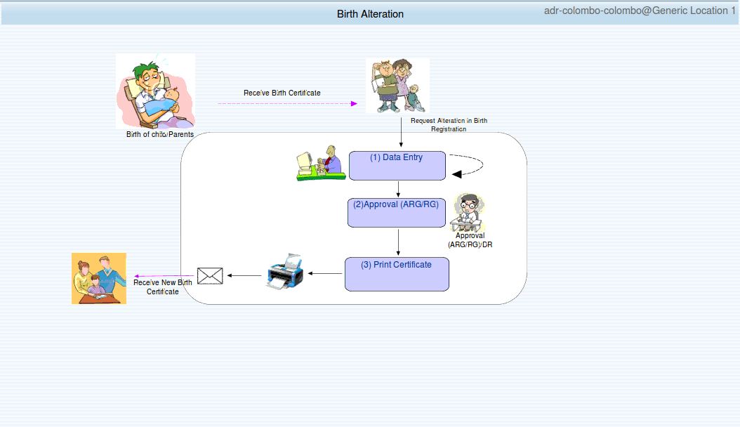Figure 4.4.1: birth alteration home page

Birth Registration Alterations
Under this section system users can find existing non archived birth records for add a new alteration under act 27. 27A ,52_1.

Searching birth record for an alteration.
- Search by birth certificate number
- Search by Person Identification Number (PIN)
- Search by birth registration division and birth registration serial number

Search by birth certificate number
steps for searching
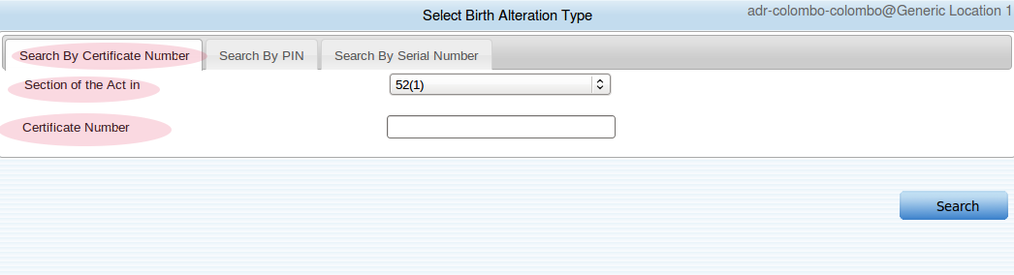Figure 4.4.1.1.1.1: search by certificate number

- Enter death certificate number (the number printed on the birth certificate)
- Select act , available acts : (27 , 27/A , 52_1 )
- Click search

If successful match found this will load alteration form with requested act .

Search by Person Identification Number (PIN)
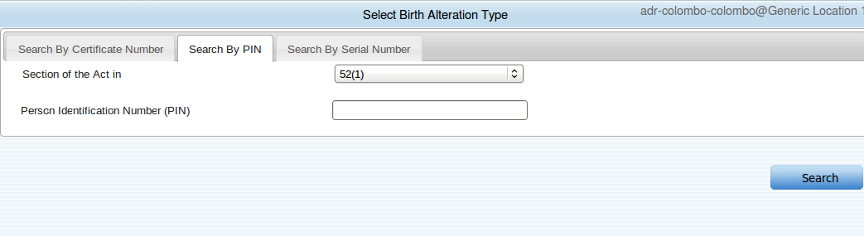Figure 4.4.1.1.2.1: search by pin

steps for searching
- Enter death persons PIN number (this is not supported for NIC numbers)
- Select the act
- Click search

If successful match found this will load alteration form with requested act

Search by birth registration division and birth registration serial number
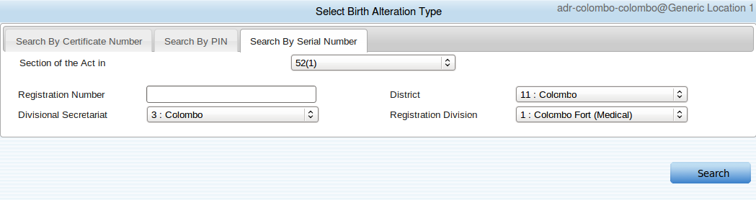Figure 4.4.1.1.3.1: search by serial number and birth division
steps for searching
- Enter birth registration serial number
- Select the birth registration division
- Select the act
- Click search

If successful match found this will load alteration form with requested act

Alterations under section 27
Alteration form is filled with existing birth certificate values when it is loaded.
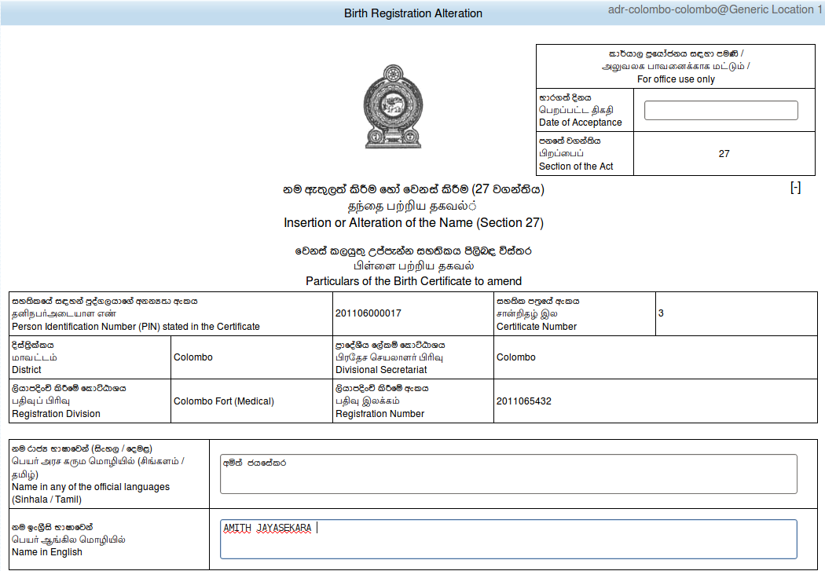Figure 4.4.1.2.1: section 27 part 1

Inputs and expected values

Date of Acceptance
- Must be in valid date format .(see section for valid data format)
- Future dates are not allowed .

Name in official language
- Filled with existing name in official language.
- For an alteration change the value that exists.
- Maximum 600 characters are allowed for type.

Name in English language
- Filled with existing name in English.
- For an alteration change the value that exists.
- Maximum 600 characters are allowed for type
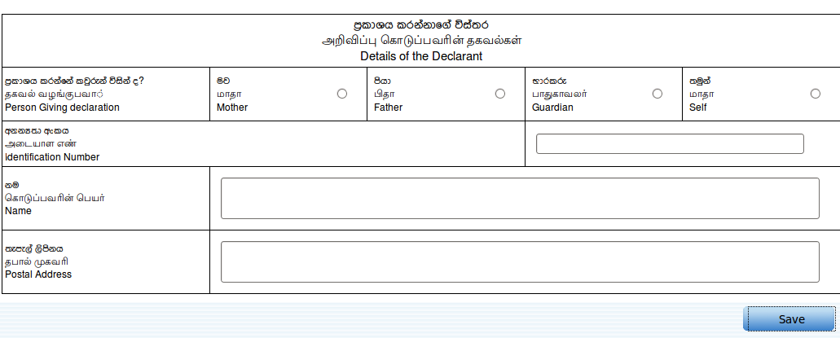figure 4.4.1.2.2: section 27 part 2
Inputs and expected values

Person giving declaration
- Capture who made the alteration this can be either Mother, Father , Guardian or Self
- Must select a value.

Identification number
- The identification number of the declarant this can be either NIC or PIN number (see section xxx for valid formts)

Name
- Name of the declarant .
- Maximum 255 characters are allowed.

Postal address (This should be filled for printing postal address at birth alteration notice letter)
- Postal address of the declarant.
- Maximum 255 characters are allowed.

After changing appropriate value click Save for adding birth alteration for selected birth certificate under section 27.

Alterations under section 27 A

Special notes for adding birth alteration under section 27 A

- All the existing values are filled when page is loaded
- To enable editable version of the sections click edit button

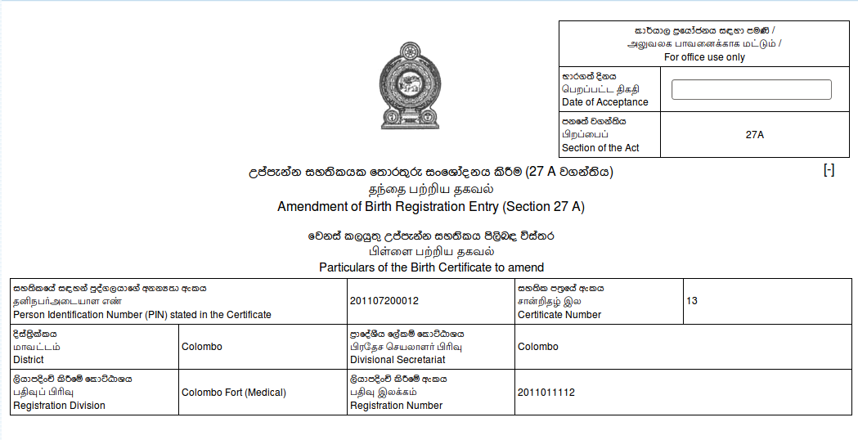Figure 4.4.1.3.1: section 27 A part 1

Inputs and expected values

Date of Acceptance
- Must be in valid date format .(see section xxxx for valid data format)
- Future dates are not allowed .

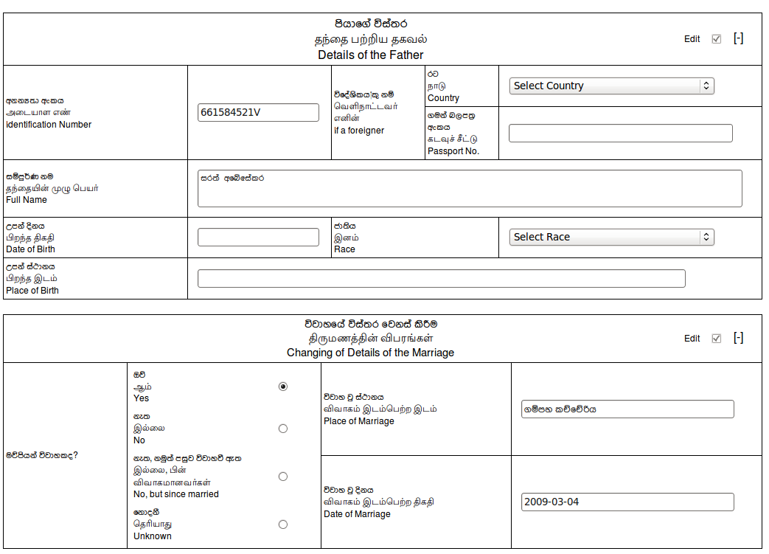figure 4.4.1.3.2: section 27 A part 2
Inputs and expected values

Details of the father

Identification number
PIN or NIC number of father (see section 7 for valid formats)

If a foreigner
Country
select the father's country from the list

Passport number
enter father's passport number which is issued by above selected country
(see section 7 for valid passport number format)

Father full name

To change father's full name change the value that already filled
Maximum 600 characters are allowed.
Date of birth
father's date of birth (see section 7 for valid format)

Race
father's race , select a value from list

Place of birth
father's place of birth.

Details of Marriage

whether parents are married
select a value from four options

fill place of marriage and date of marriage if and only if whether parents are declared as married.
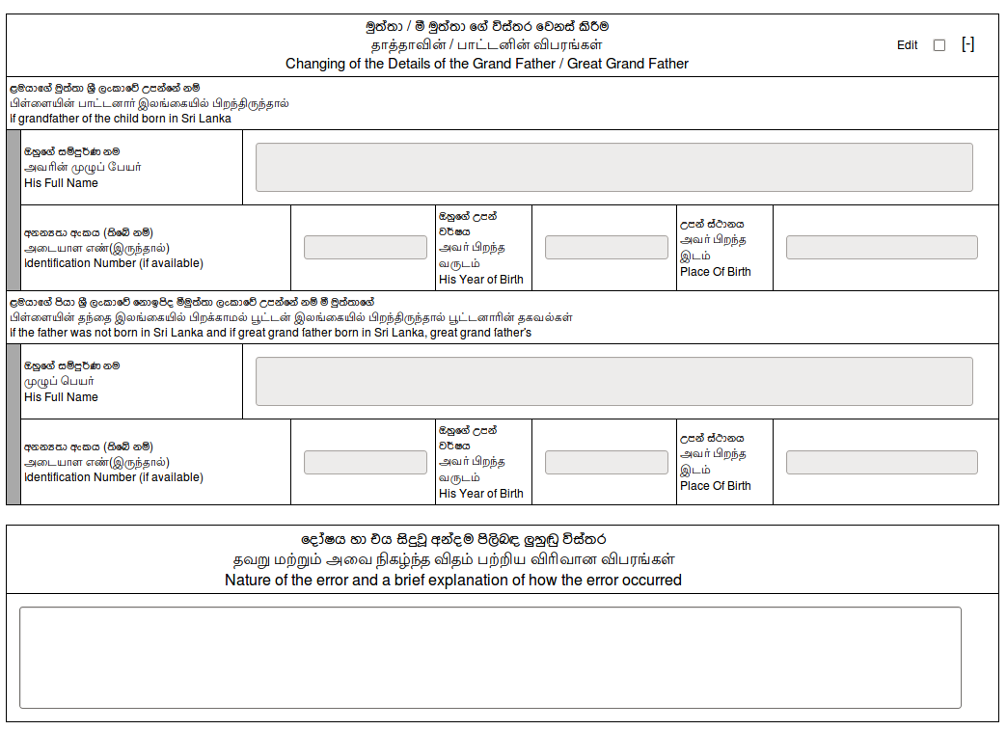figure 4.4.1.3.3: section 27 A part 3
To enable edit mode click edit button at top left corner and to minimize or maximize the section click
[-] or [+] at top left corner

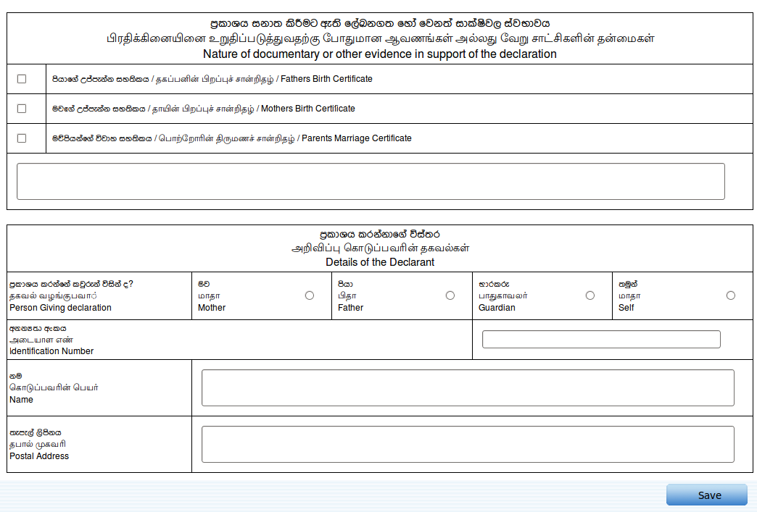figure 4.4.1.3.4: section 27 A part 4
- User must enter who giving the declaration for that select an option among the mother, father guardian or self .
- It in not necessary to fill other details under details of declerent section but for print alteration notice letters address and name of the declarent is needed so it is advised to fill that as well.
- If any case user unable to fill the address or the name of the declerent and if the alteration being approved then there is no chance to come back and change the data so notice letter wont print the address and the name of the declerent .
- User can specify more than one evidence documents. If the evidence document is not specified under the section type the evidence inside the given text area.

Alterations under section 52 _1

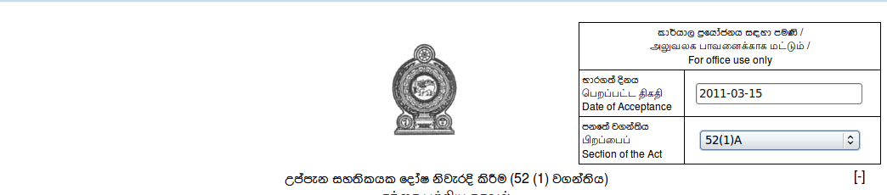Figure 4.4.1.4.1: section 52(1) part 1
Date of acceptance
- Future dates are not allows as data of acceptance.
- See section 7 for valid date format.

Section of act
- Select particular section.
- Available options (52(1) A / 52(1) B / 52(1) D / 52(1) E /52(1) A /52(1) H/52(1) I).

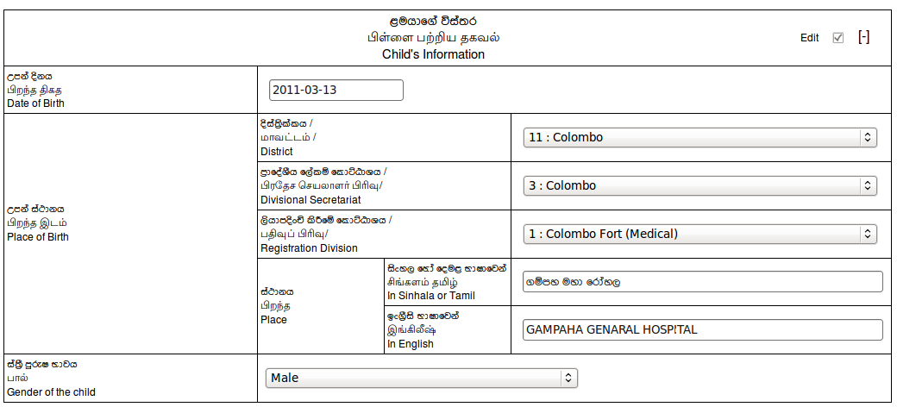figure 4.4.1.4.2: section 52(1) part 2
- User can change details under child informations.
- Date of birth must be in valid date format.
- See section 7 for valid date format.

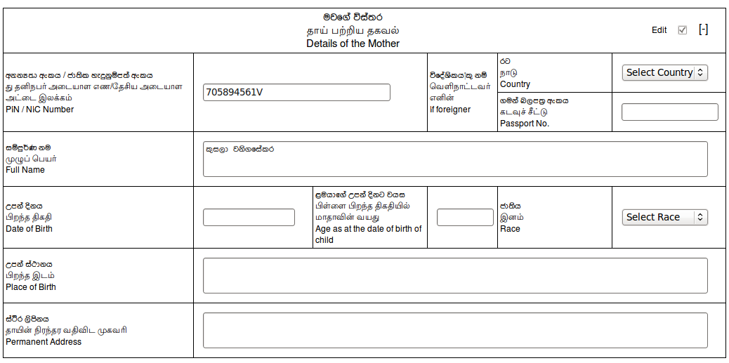figure 4.4.1.4.3: section 52(1) part 3

- User can change details under mother informations.
- PIN or NIC must be in their respective formats
- See section 7 for valid NIC ,PIN and Passport number formats.

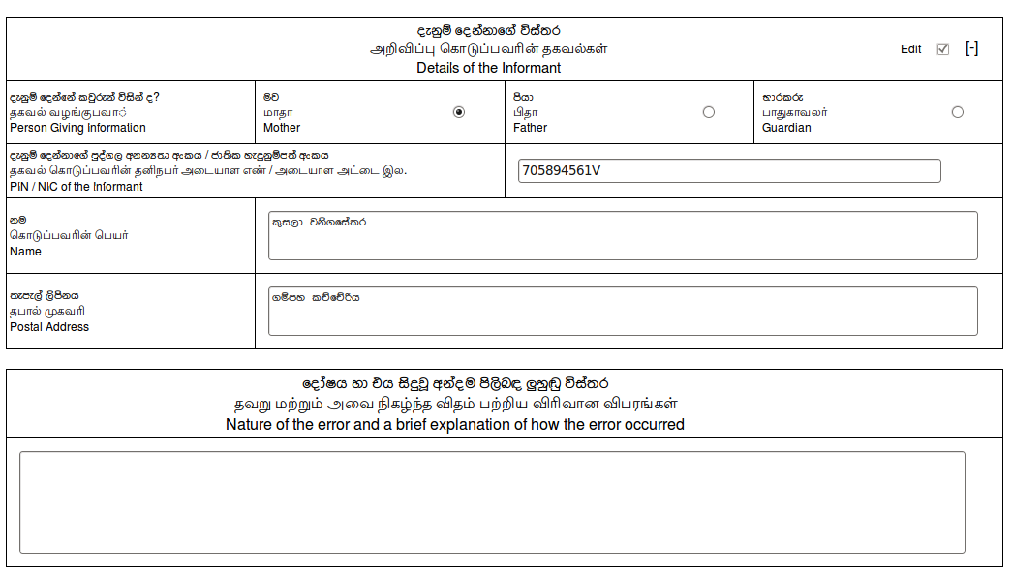figure 4.4.1.4.4: section 52(1) part 4
- Change declerent informations under this section.
- PIN or NIC of the declerent must be in their respective formats.
- See section 7 for valid formats of PIN and NIC.

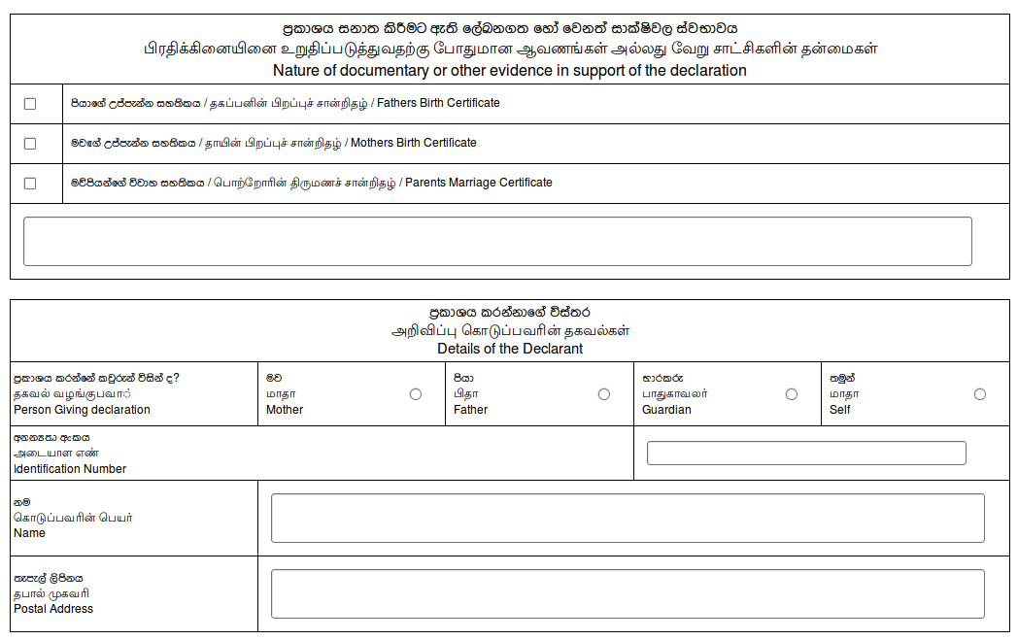figure 4.4.1.4.5: section 52(1) part 5
Check same section under alteration 27 or 27 A for how to fill details under this section

Possible errors and messages

While searching birth record for alteration .
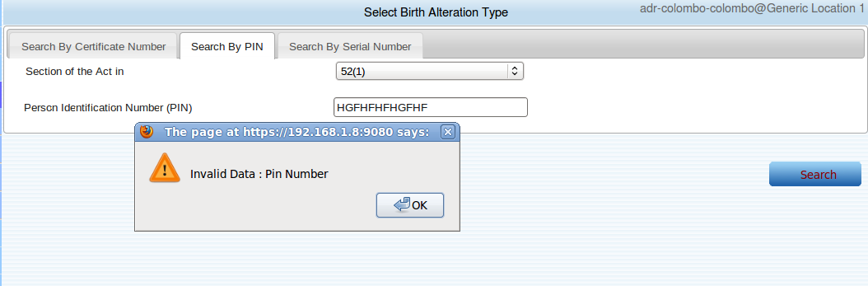
Reason for the error : entered PIN number is not in correct format
(see section 7 for correct PIN format)

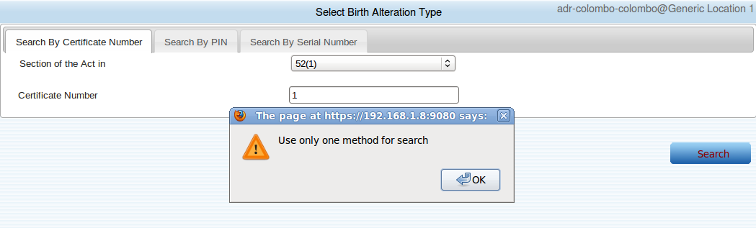

Reason for the error : User have used more than one mechanism for searching.
Ex : User may have entered both PIN number and Serial number
how to avoid : Use only one searching mechanism.

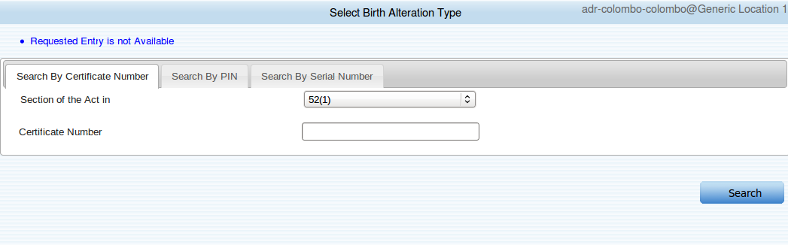
Reason for the message : User has requested a non existing birth record for an alteration

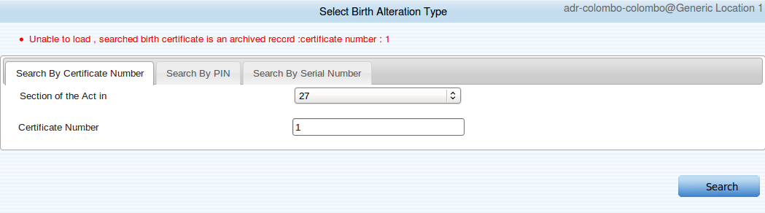

Reason for error message : The requested birth certificate is an archived birth certificate .

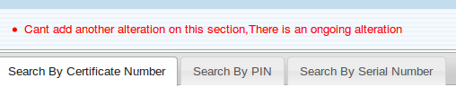
Reason for error :
- For a given birth certificate user can add 3 types of alterations.
- But until a particular alteration is being approved , user can not add another alteration under same section .
- Reason for the error is user try to add another alteration for a birth certificate under same section and there is an another unapproved alteration under this section.

Birth Alteration Approval

Following functionalities are available under this sub menu
- Search a already entered birth alteration
- Edit a birth alterations
- Reject a birth alteration
- Approve a birth alteration
- Delete a birth alteration

Birth alteration approval home page
When this page load it is automatically load with the alterations that made for user's preferred
birth / death division as the follow image show there are three alteration are available for this user's preferred division (colombo medical).
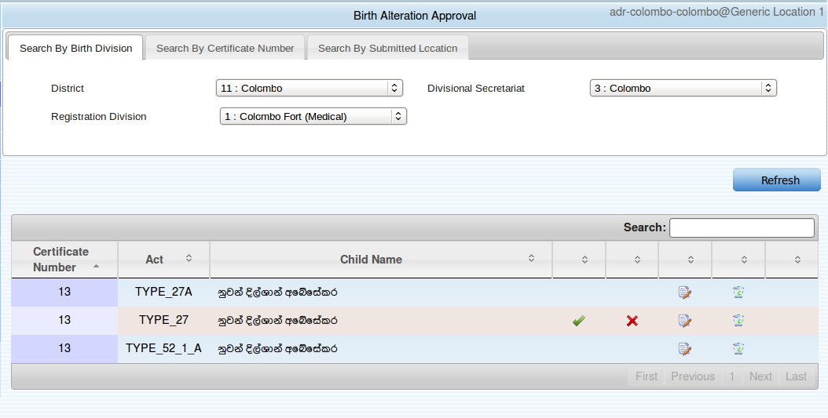

How to search a birth alteration.

Follow is a simple scenario to demonstrate how to search a birth alteration.
- Assume there is a birth certificate which is registered on colombo birth /death division.
- And assume that an user from gampaha birth/ death division is adding alteration for that certificate
- Now there are two parties can search that birth alteration
- Users from location that made the alteration
- Users who are assigned to the birth / death division which originally birth is registered
- Those two types of users can search that alteration.
- With respect to above example only users form gampaha location (where alteration add ) and users who are assigned to the colombo medical birth / death division can see the alteration.

Search by birth division.
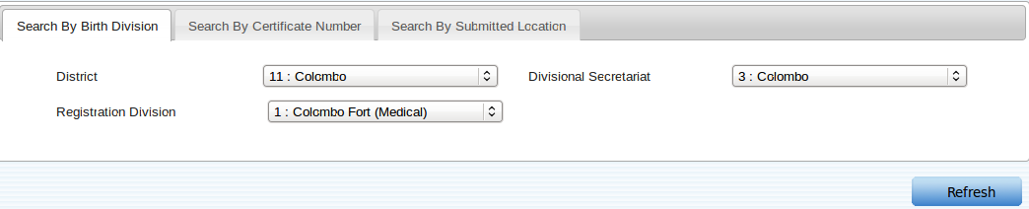
Steps for search
- Select a birth division form the list
- Click “Refresh “ for search.
This will load all the alterations made by given birth division

Search by birth certificate number Steps for search
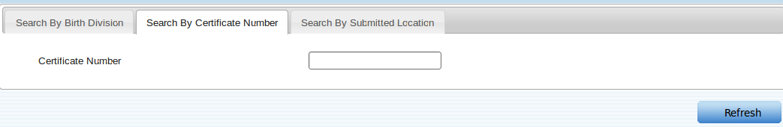

- Enter birth certificate number (see section 7 for valid format)
- Click “Refresh” for search
This will load all the alteration that made for given birth certificate.

Search by user's location
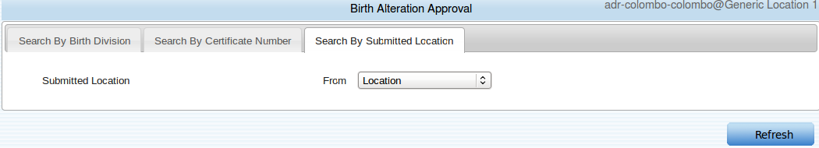
Steps for searching
Select a location form the list.
Click “Refresh” for search.

This will load all the alterations that made from this location.

Possible errors and message while searching a birth alteration for modify
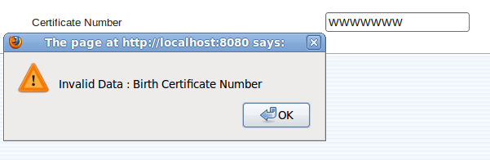
Reason for error :
Entered birth certificate number is not in correct format .(see section 7 for correct format)

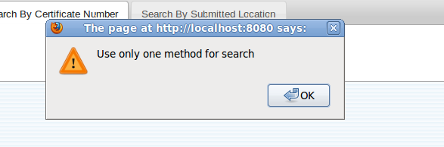
Reason for error:
User has used more than one searching mechanisms .
How to avoid ;
Clear a one mechanisms.

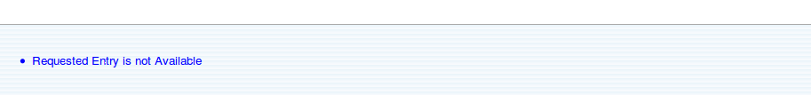
Reason for message :
Searched birth alteration is not available.

Sample birth alteration approval table
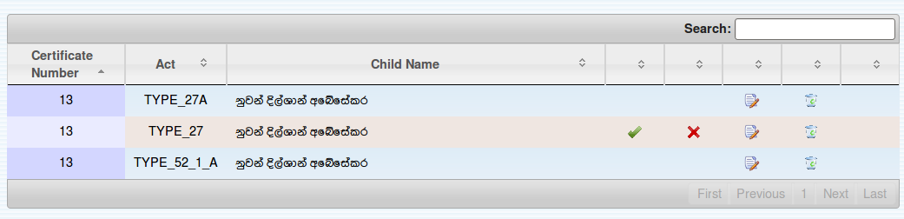

What inside this table
Certificate Number
- The birth certificate number which is alteration made .
Act
- Section of the act
Child Name
- Child's name as in birth certificate (this will be empty if there is not a name given in birth certificate
Icons
- See appendix xx for meaning of icons

How to edit a birth alteration
Any user can edit a birth alteration (alteration that user allows to edit) if that alteration is not approved or rejected .

- To edit a birth alteration user has to search for the particular birth alteration ,for that see section 4.4.2.2 .
- After searching for the alteration click “edit” icon for open the alteration in editable mode
- Then change the existing values and click “Save” button.
- Once successfully apply the changes screen will be as follows.

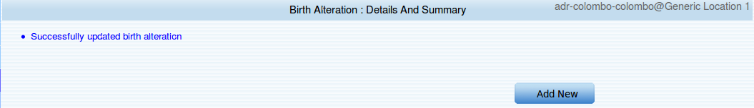

      - If user get this message that mean the changes are applied to the birth alteration .
      - If user need to add another alteration for a particular birth record click “Add New” button
      - It will foreword user to birth certificate search page for alterations.

How to delete a birth alteration

Any user can delete a birth alteration (alteration that user has permission to delete ) if that alteration is not approved or rejected.

- To edit a birth alteration user has to search for the particular birth alteration ,for that see section 4.4.2.2 .
- Once user found the particular birth alteration user can delete that birth alteration by clicking delete icon.
- I f user does not get any error messages that mean the deletion operations is performs correctly
- After successfully deleted the table is reloaded with data that belongs to the user's preferred birth/ death division.

How to reject birth alteration
Special note:
ADR user's are Only allows to reject alteration that made under section 27

- To edit a birth alteration user has to search for the particular birth alteration ,for that see section4.4.2.2 .
- Once user found the particular birth alteration user can reject that birth alteration by clicking reject icon.
- Once user click reject user will get following screen.

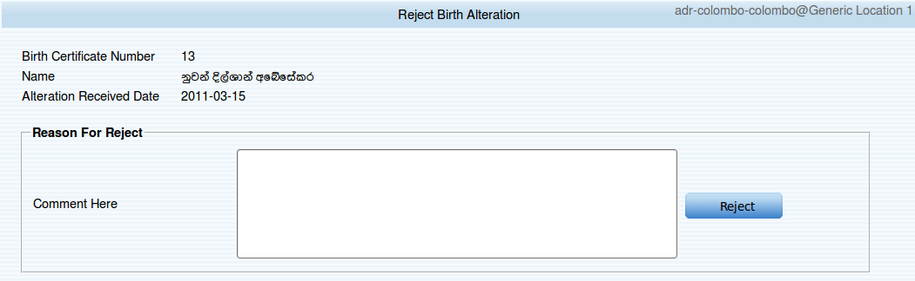
- To reject a birth alteration there must be a reason .
- Insert the reason for rejecting inside the given space.
- After adding click “Reject” for rejecting birth alteration.
- If rejection process is successfully completed user will get a screen as follows.

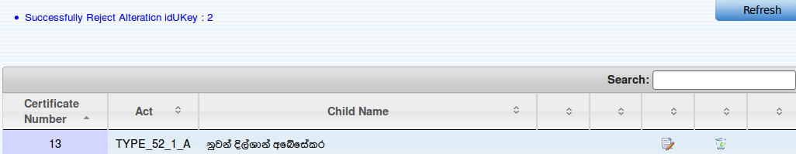
- Message displays that rejection process is completed successful for birth alteration and it gives the birth alteration serial number which the rejection is taken place .
- And after rejection table will be loaded with the alteration data that belongs to the users preferred birth / death division

possible errors and messages while rejecting a birth alteration

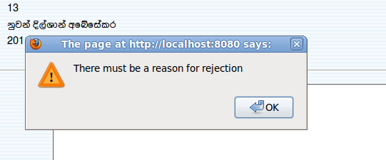
Reason for error :
User forgot to add a reason for rejecting birth alteration.
How to avoid
Add a reason for rejecting.

How to approve a birth alteration

Special note:
ADR user's are Only allows to reject alteration that made under section 27

- To edit a birth alteration user has to search for the particular birth alteration ,for that see section 4.4.2.2 .
- Once user found the particular birth alteration user can approve that birth alteration by clicking approve icon.
- Once user click approve icon user will get following screen.
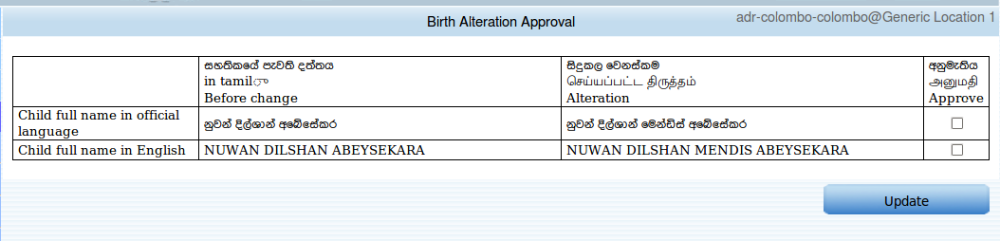
- This screen display altered value with respective to the original birth certificate value.
- User can approve any of the changes by clicking check boxes.
- Once user selecting all the changes that going to approve click “Update” button and following warning message will be displayed.

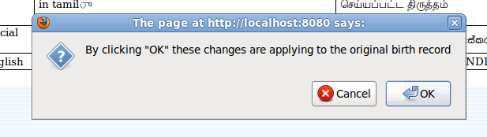

- If user click “OK” it will completed the approval process and if user click “Cancel” user will remain in that page
- If user click OK user will get following screen.
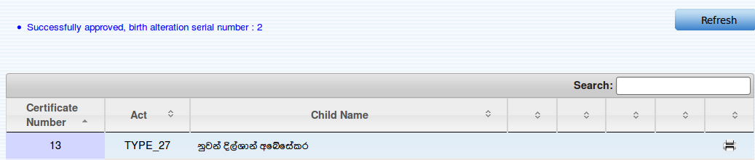
- It show that alteration is approved successfully .
- Now user is allows to print the alteration notice letter (check the data table there is another new print icon is enabled for that ).
- And a new not printed birth certificate is generated with new altered values. User can find that certificate (see section 7 for how to print birth certificate) and can print new birth certificate.

How to print birth alteration notice letter.
- To print a birth alteration notice user has to search for the particular birth alteration ,for that see section 4.4.2.2 .
- Once user found the particular birth alteration user can print that birth alteration notice letter by clicking print icon.
- Follow is a sample birth alteration notice letter.

That notice letter is consists with two parts
- Notice letter for alteration applicant (mail to applicant)
- Notice is to be shown at Grama Niladhari office(issue for Grama Niladhari)

There are two printing options (see follow image )
- Print Complete
- Print
if user select Print Completed option syatem will capture the data that who is printing the notice and the process of birth alteration ends and treated as birth alteration notice is printed. And if Print select system do not capture any details and it is still treated as not printed birth alteration notice .
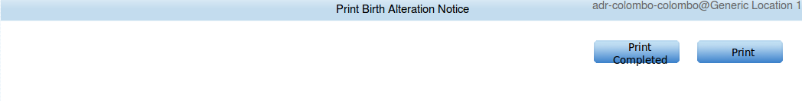
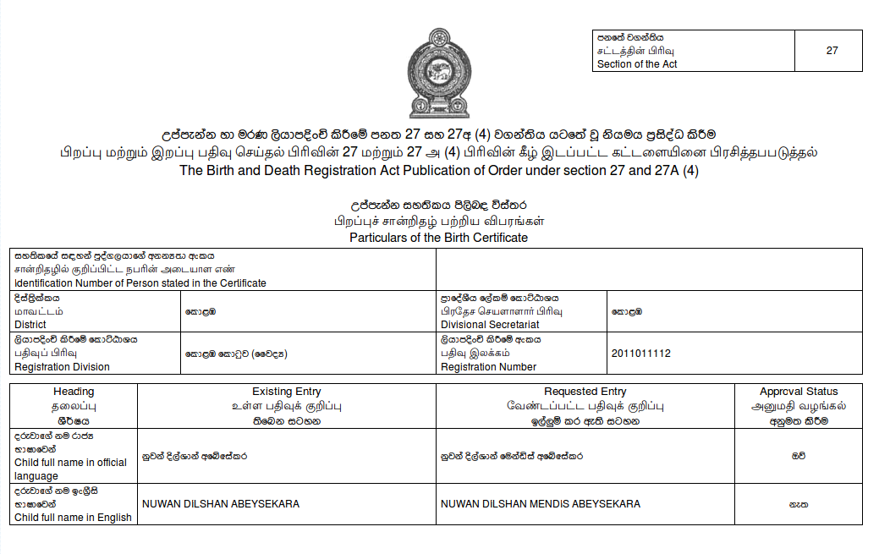 figure 1: notice that issue for grama niladhari for showing at office
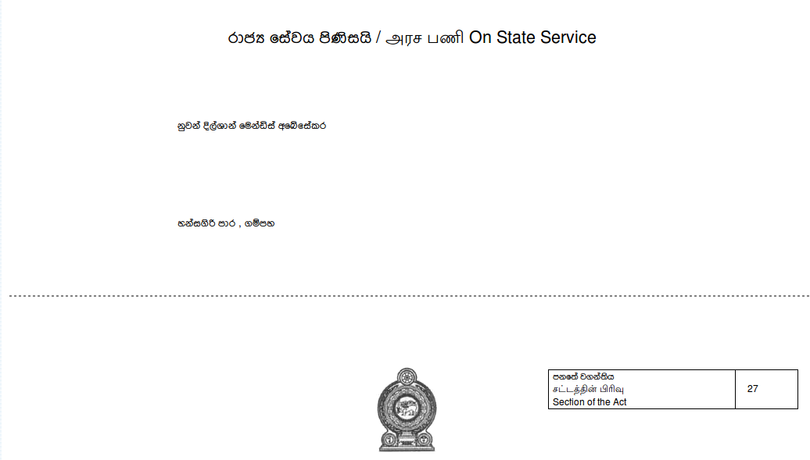

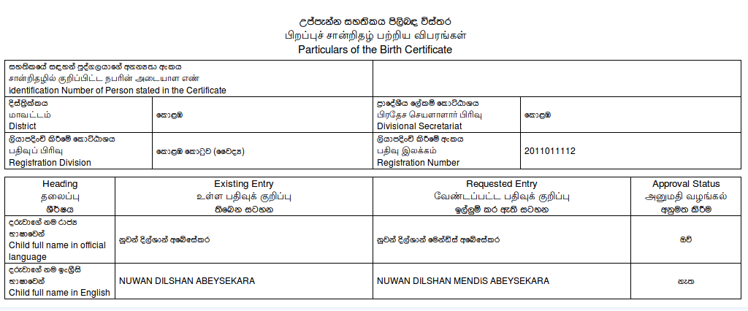 figure 1: birth alteration notice letter with applicant address

Death Registration Alteration

Manage Death Alteration

User Preferences
Basic functionalities of this section.
Change password of user
Change user's preferred language.
Change user's preferred district.
Change user's preferred D.S. Division.

User Preferences

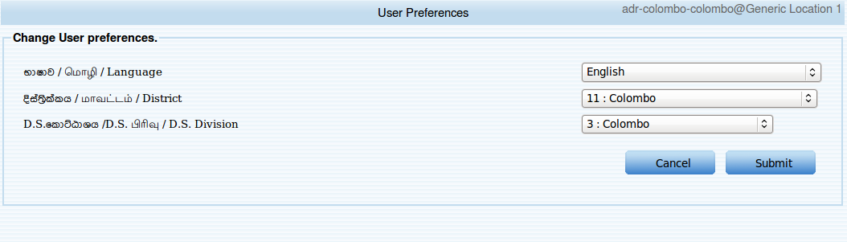Figure 4.5.1.1: change user preference

Changing preferred language
This feature enable to change users preferred language in the system. User can use either SINHALA
,TAMIL or ENGLISH as the user's preferred language.

Step for changing preferred language
- select preferred language from the list.
- Click submit
- After successful change total system language change to selected language.

Changing preferred district and ds division.
If user is assigned to multiple districts and multiple ds division user can name one as it's preferred district or ds division.

Steps for changing district and ds division.
- Select user's preferred district and ds division from list .
- Click submit .

Change Password
- This feature enable user to change user's password for login to system. It is advised to change password more frequently .
- Do not set password to easily guess one .
- Password must contain any combination of following rules.
- Password must contain at least one (1) upper case letter.
- Password must contain at least one (1) lower case letter.
- Password must contain at least one (1) number or special character.
- Password must be at least eight (8) characters in length .

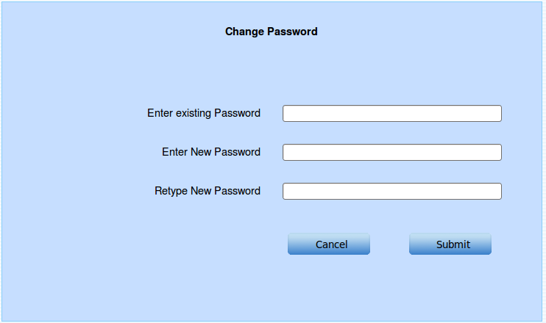Figure 4.5.2.1: changing password

Steps for changing password
- Enter existing password
- Enter new password
- Re type new password
- Click “Submit” for change or “Cancel” for cancel the operation.
- After successful password change user will be forward to user's home page .

Possible errors while changing password.

Figure 4.5.2.1: error1
Reason for error
User is unable to fill all required fields.
How to avoid
Fill all required fields.
Figure 4.5.2.2: error2
Reason for error:
Entered existing password is not match with user's existing password.
How to avoid
Re enter user's correct existing password.

Figure 4.5.2.3: error3
Reason for error:
Entered values as new password and retype new password are not equal.

Figure 4.5.2.4: error4
Reason for error :
Entered new password is not strong enough

Sample strong passwords
Password1!
123@#Pass

PRS

Person Registration

Person Records Search

Person Registration management

Search Records

Birth Deceleration/Confirmation Search

Birth Certificate Search

Death Certificate Search

Birth Records Search

Admin Task

Manage Assignments

Add Registrars

Search Registrars

Marriage Registrations

Marriage Notice

Marriage Notice Search

Marriage License Search

Marriage Registration

Marriage Register Search

Icons

Special Tools

Using date picker

Using time picker

Using data tables

Valid Input Formats

Serial number
- A 10 digit number
- Unique for a given birth/death/marriage division.
- Valid format yyyy{1|0}xxxxx
yyyy = current year
{1|0} = 1 for registration at DS office and 0 for registrars office
xxxxx= unique number for given birth/death/marriage division.

Sample serial numbers
2011112345
2011012345

Date
- Must be in iso8601 format (yyyy-mm-dd)
Sample dates
1986-08-21

Time
- Must be in standard 24 hrs format (HH:MM)
Sample times
15:30 for 3:30 pm
09:30 for 09:30 am

Certificate Number
- Must be a number

NIC
- Must have 9 digits and a letter
xxxxxxxxx{X|V}
xxxxxxxxx= 9 digit number
{X|V} = 10 th letter is X or V

sample NIC numbers
861234569V
563217899X

Some invalid NIC numbers
864567896V
value of digit number 3 to 5 must be in between
If NIC owner is a male that value must be between 1- 366
If NIC owner is a female that must be between 501-866

PIN
- 12 digit unique number.

Passport
- Must be less than 12 can be include numbers and characters.

